**Hybrid Deep Learning for Detecting Novelty Seeking in Travel Reviews: Integrating BERT, CNN, and BiGRU for Improved Accuracy**

To Run the application, Click on “run.bat” file from the file location.

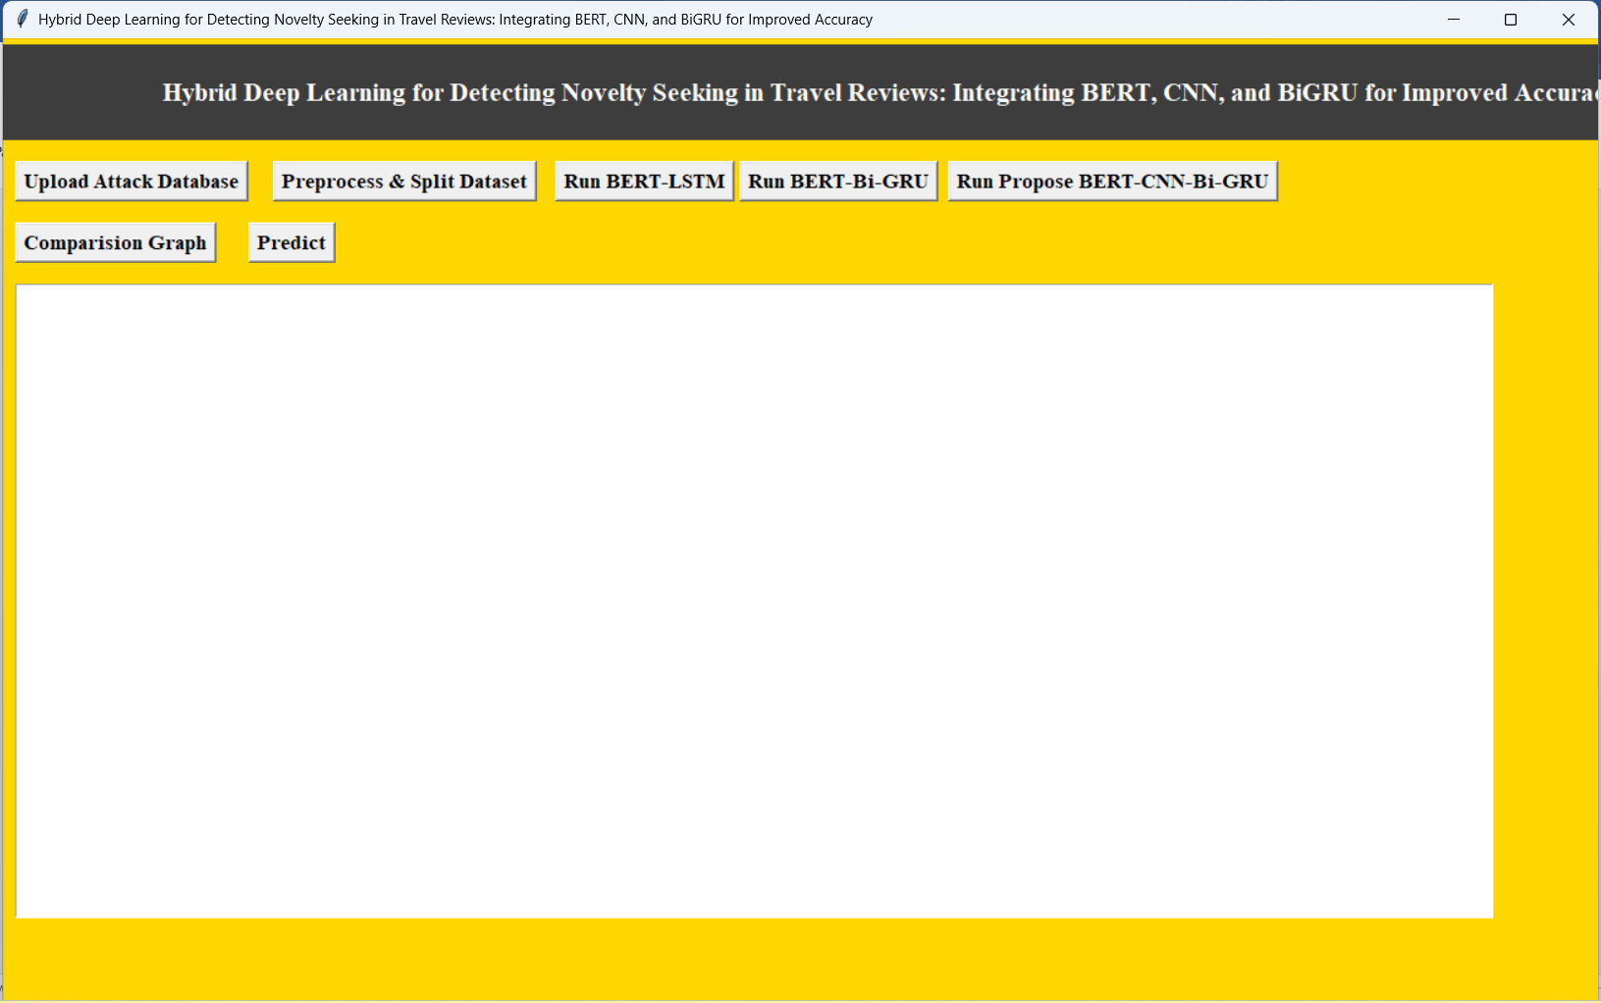

In Above screen select Upload Attack Database

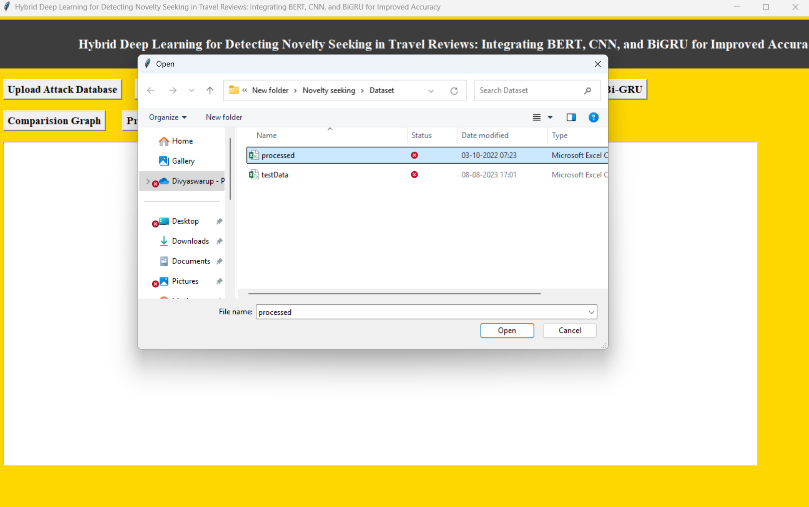

In above screen uploading processed dataset

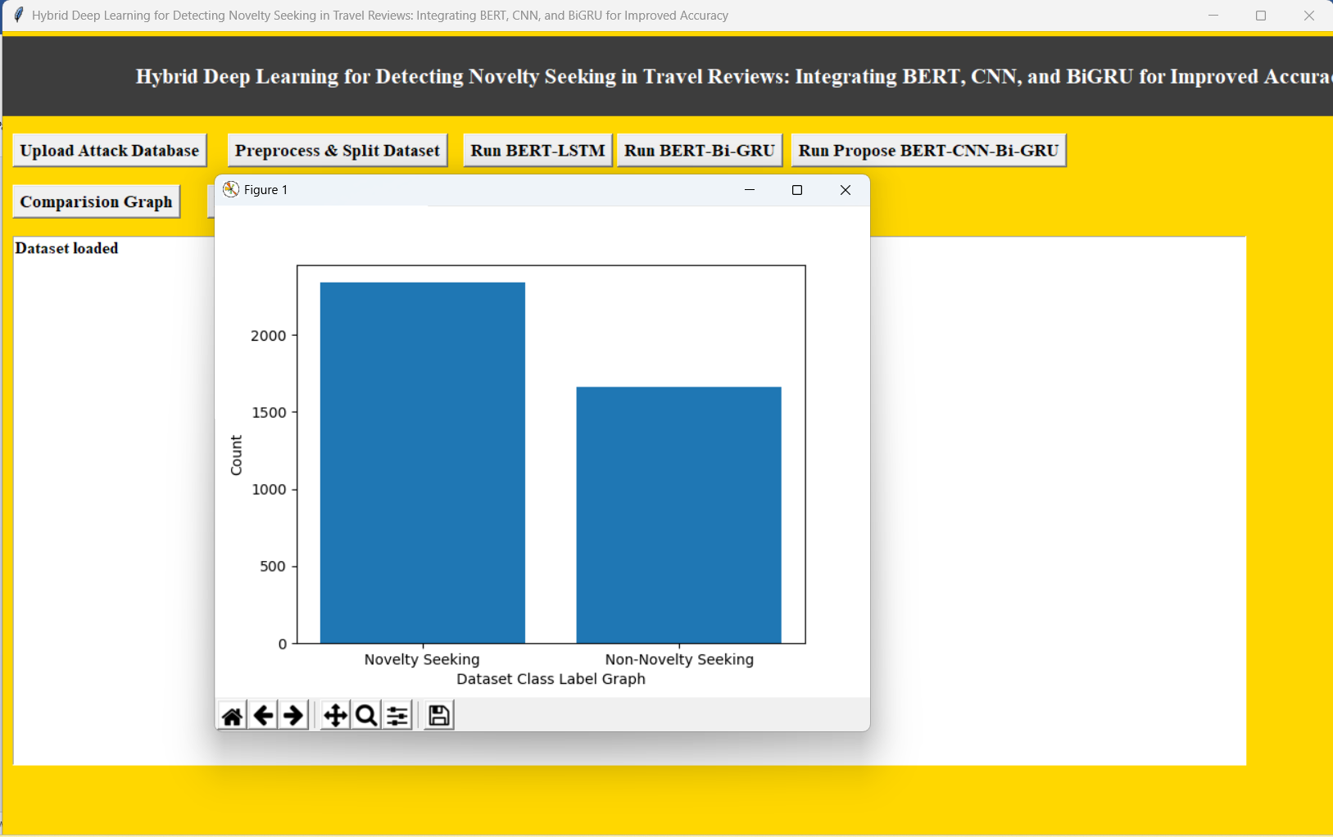

In above screen finding and plotting graph of Novelty and Non-Novelty reviews where x-axis represents novelty type and y-axis represents count

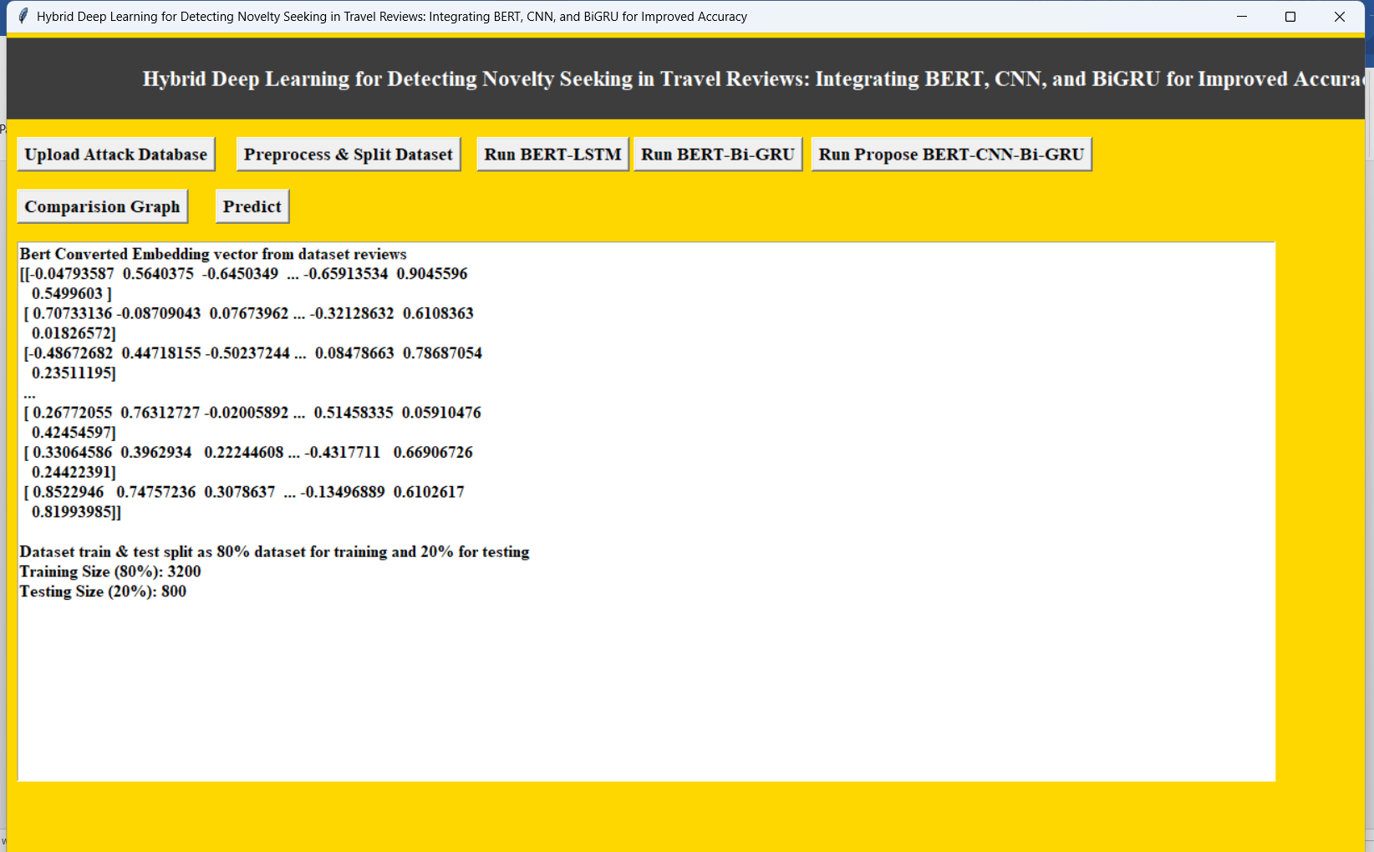

In above screen processing dataset such as shuffling and splitting into train and test and then showing output of train and test data and then defining arrays to store accuracy and other metrics values

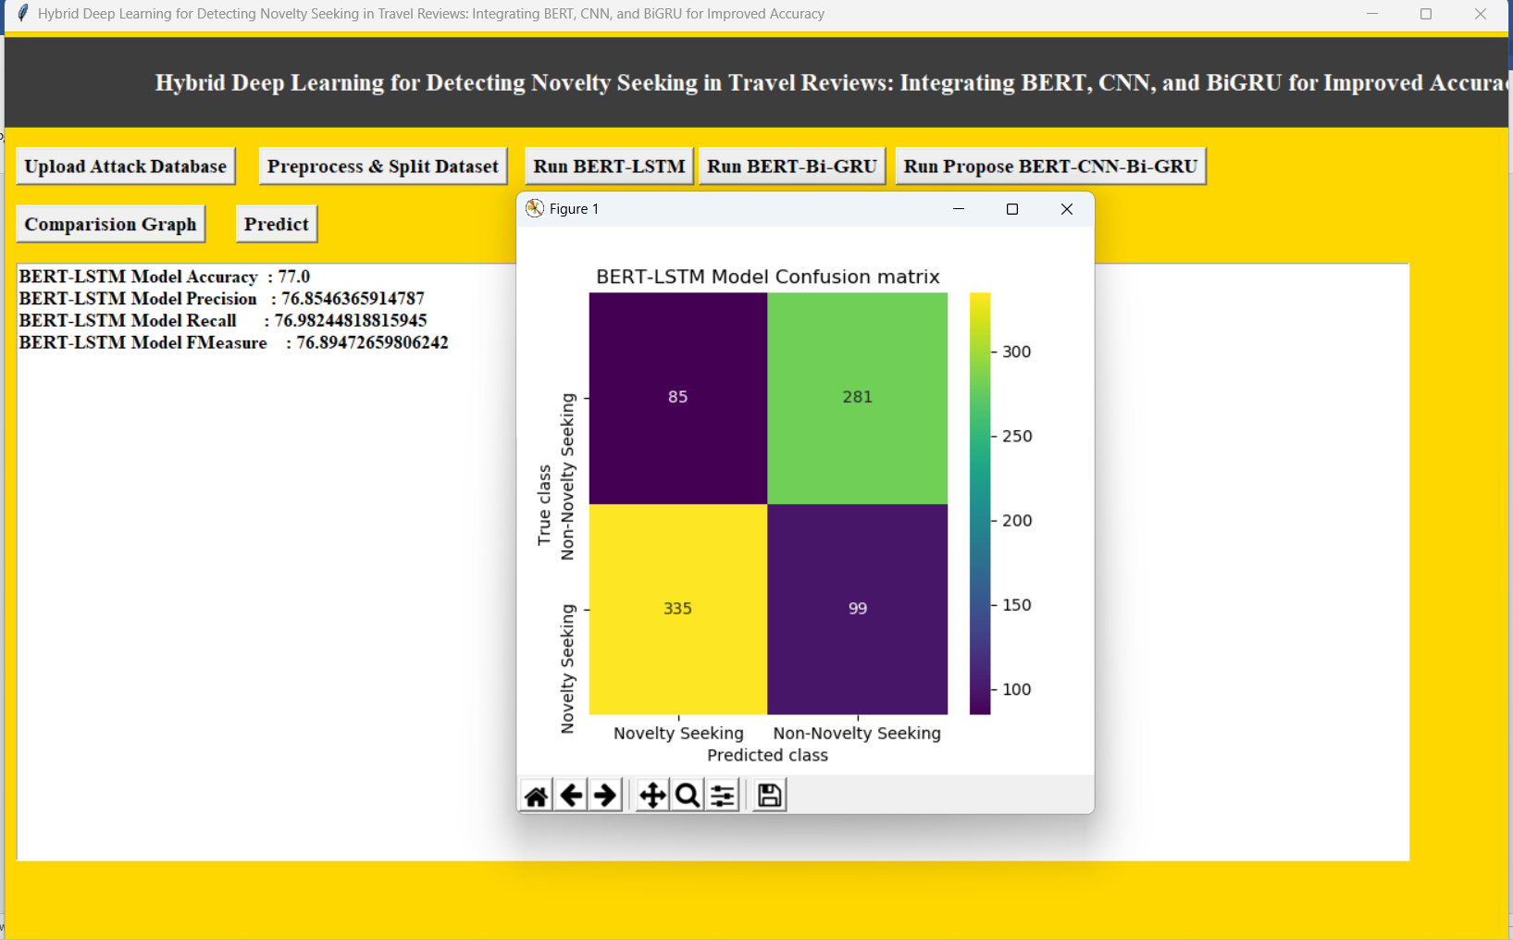

In above screen BERT-LSTM got 77% accuracy and can see other metrics also and in confusion matrix graph x-axis represents Predicted Labels and y-axis represents True Labels where different colour boxes contains correct prediction count and all blue boxes contains incorrect prediction count which are very few.

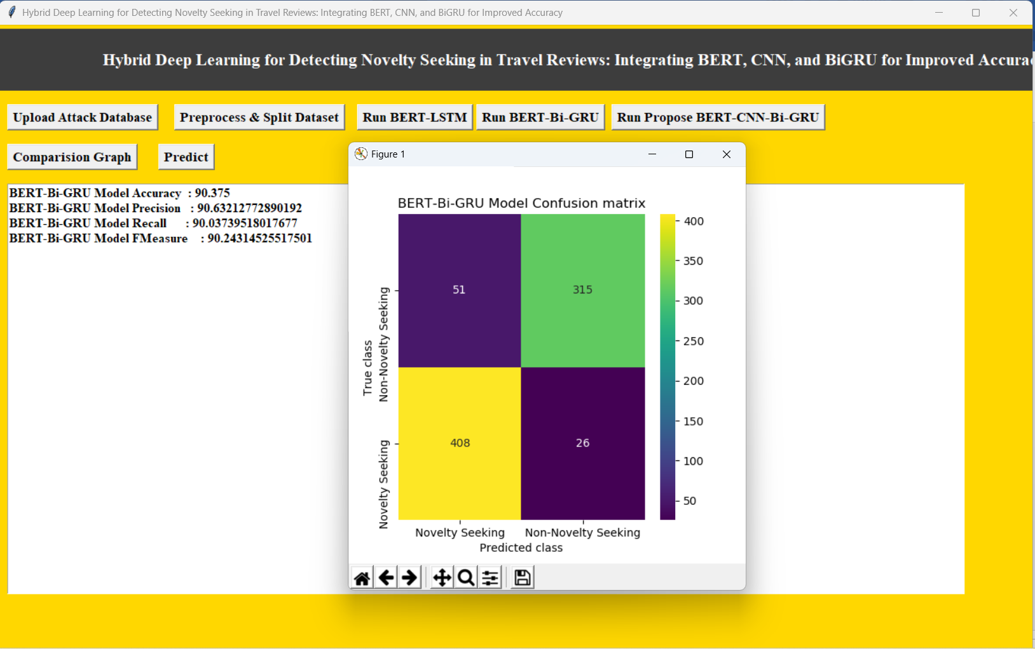

In above screen BERT-BI-GRU got 90% accuracy

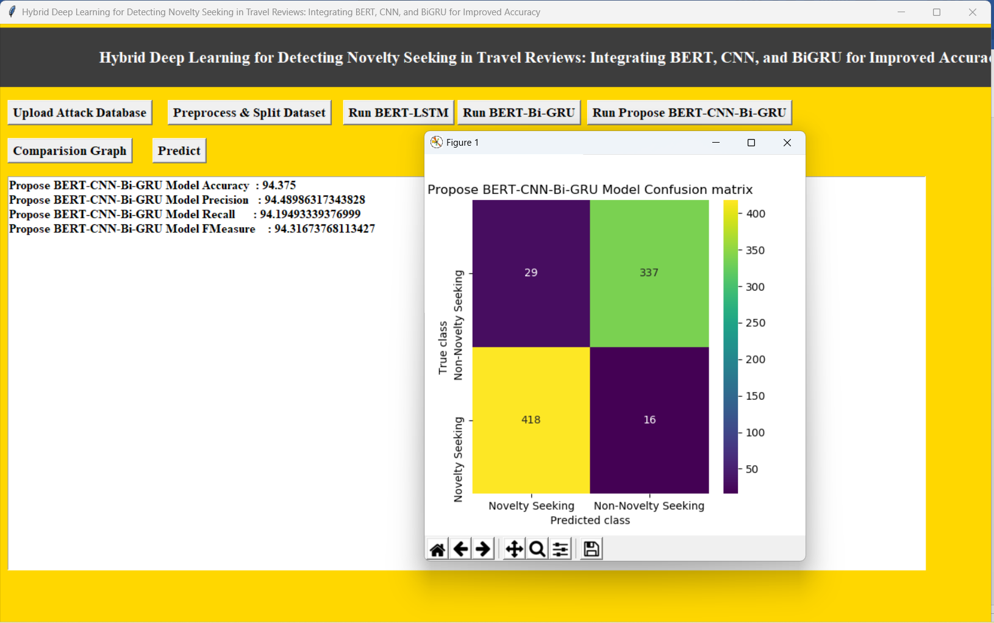

In above screen Propose BERT-CNN-Bi-GRU model got 94% accuracy

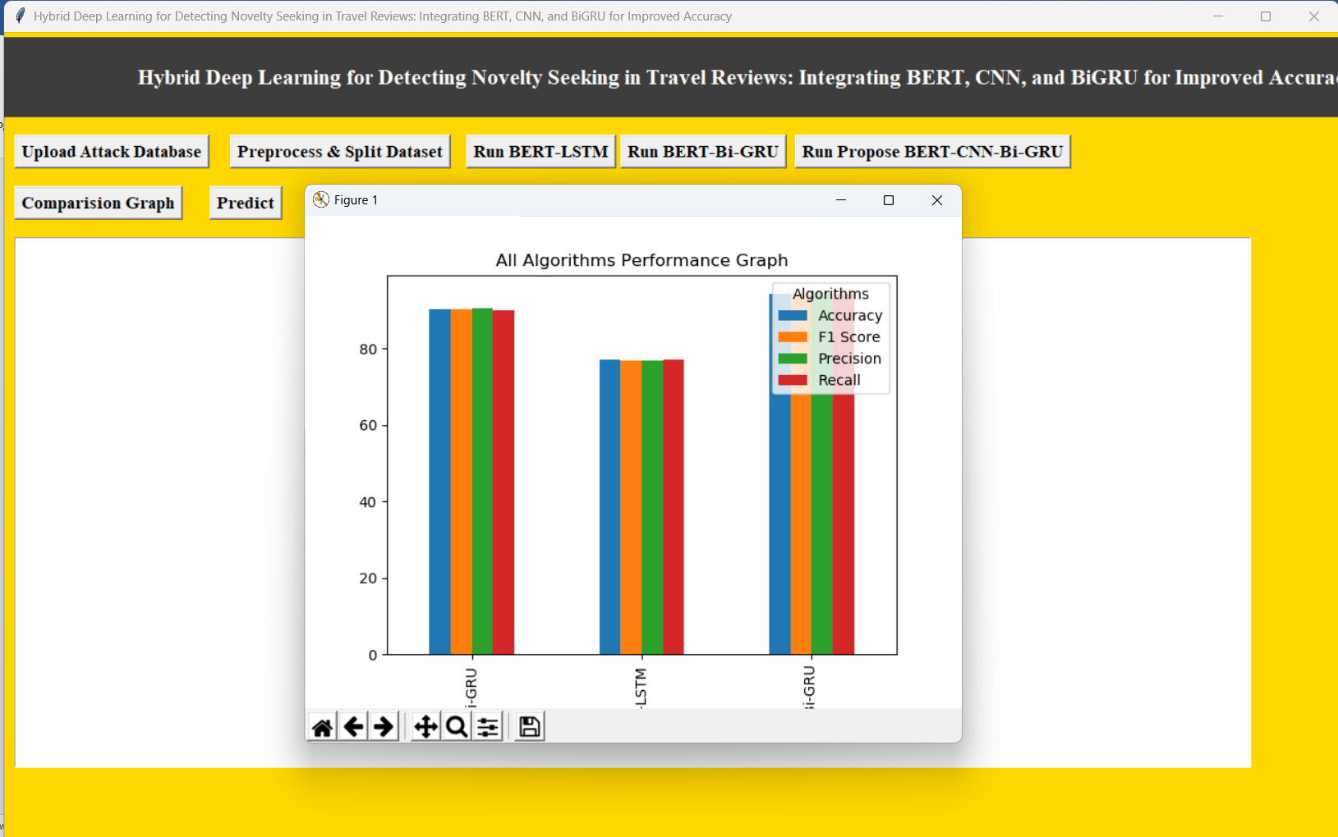

In above graph x-axis represents algorithm names and y-axis represents accuracy and other metrics in different colour bars and in all algorithms, propose got high performance

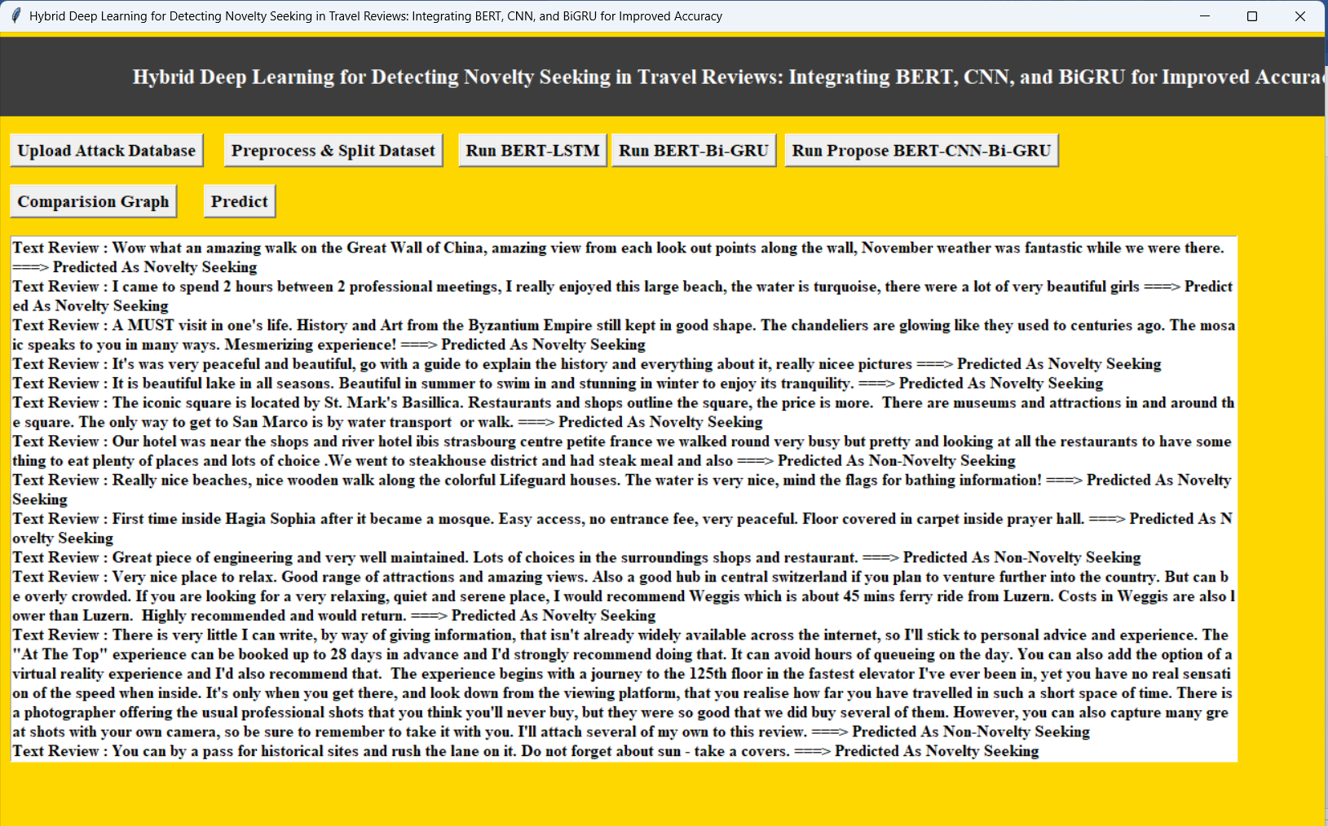

In above screen reading TEST reviews and then converting to BERT features and then using Propose model predicting Novelty Seeking or not and in output before arrow symbol we can see TEST data and after arrow symbol =🡺 we can see predicted output as Novelty Seeking or Non-Novelty seeking.